Case Study Submission template

GitHub Repository URL: <https://github.com/anilallu1405/batch10.git>

Screenshot of Dockerfile:

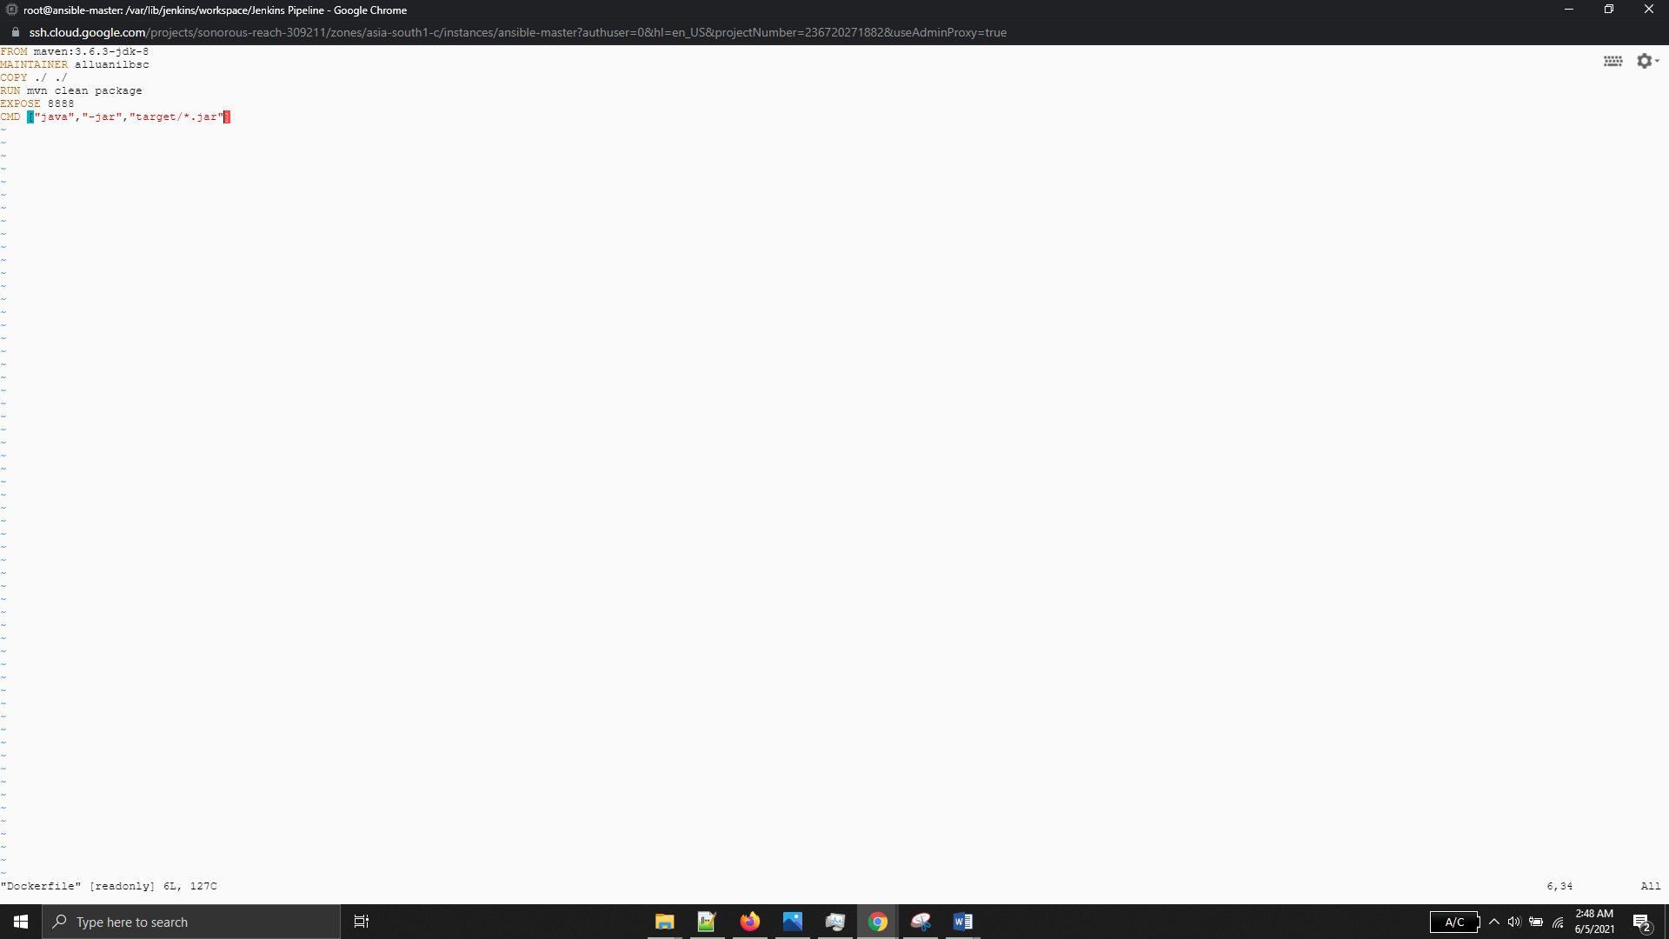

Screenshot of Jenkinsfile:

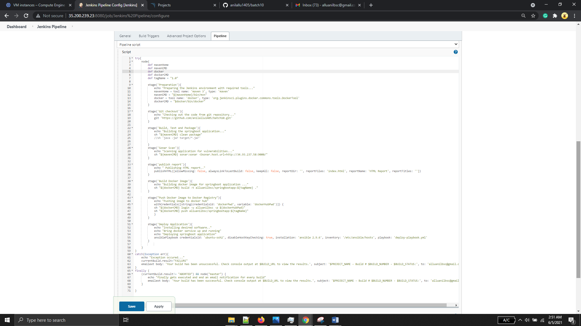

Jenkins complete log file uploaded to github repo

Jenkins Pipeline job status

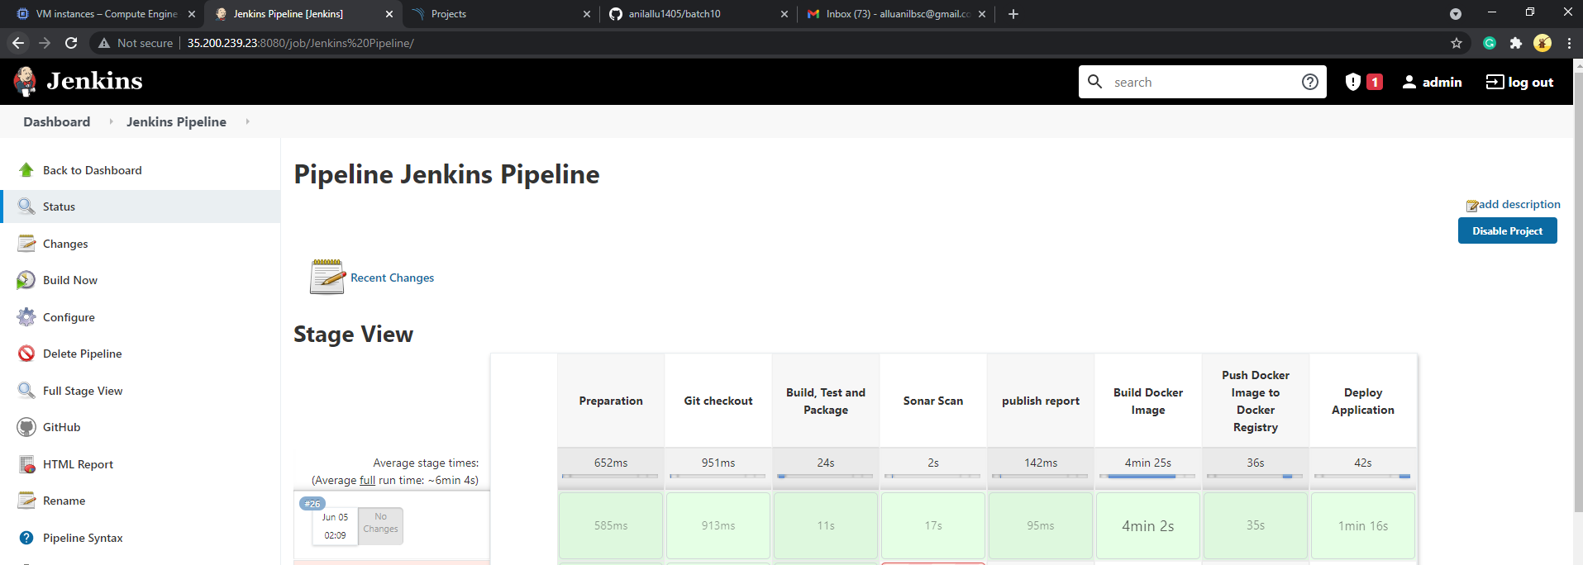

Email Notification for build

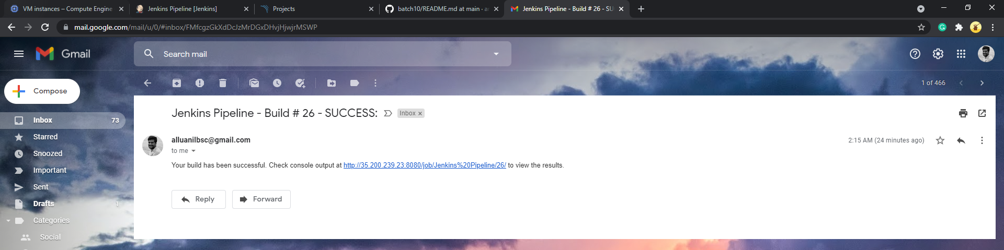

SonarQube Report

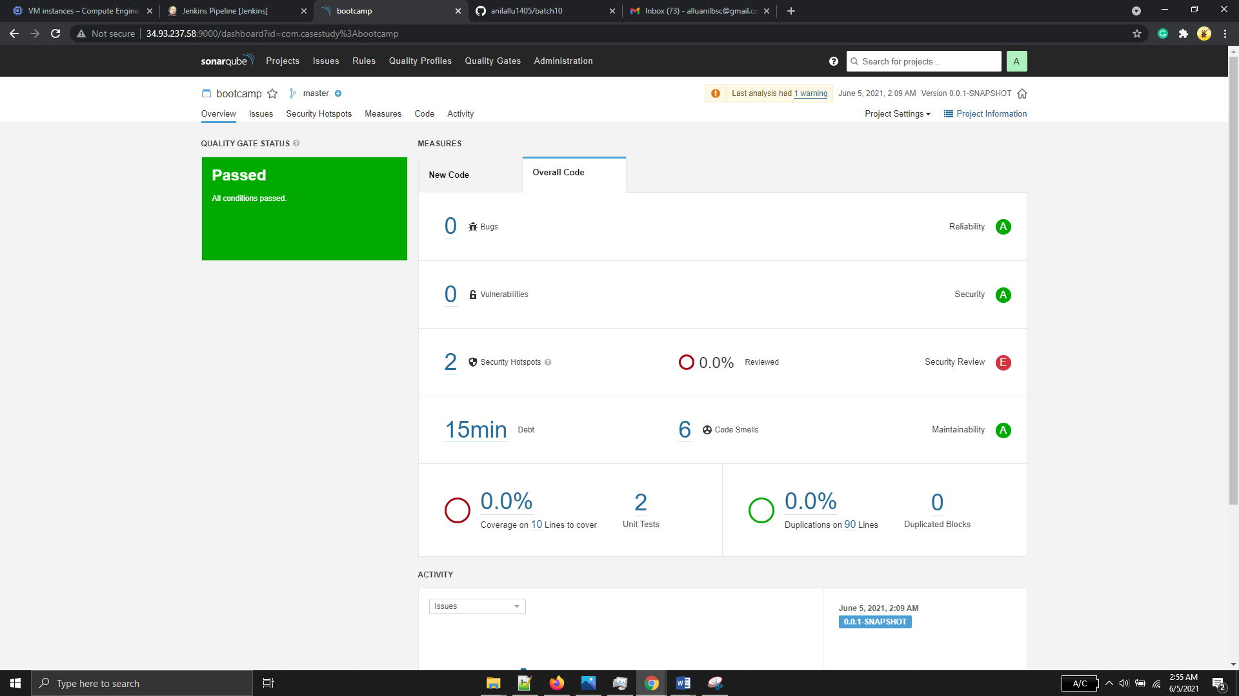

Ansible Playbook Execution logs

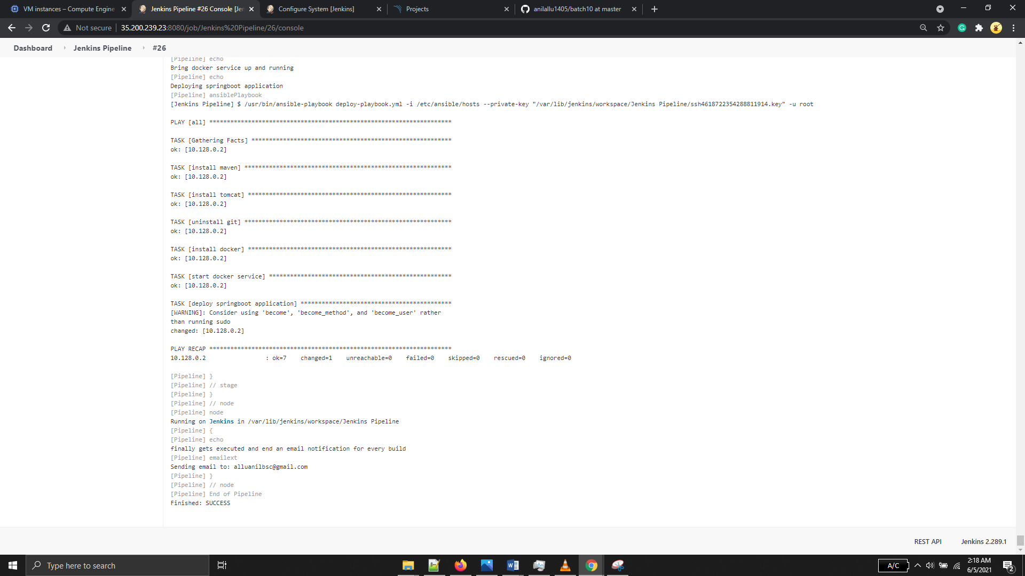

Working application in GCP

